Leveling up from coding basics, intermediate coding is where you refine your skills to build more intricate applications. Imagine graduating from baking cookies to crafting a delicious cake. You've got the fundamentals down, but now it's time to learn new tricks. Data structures become your pantry; you organize information efficiently using lists, stacks, and more. Algorithms are your recipes; you explore clever problem-solving techniques to tackle complex tasks. Object-Oriented Programming (OOP) is like pre-measuring ingredients; it helps structure your code with reusable components for better organization.

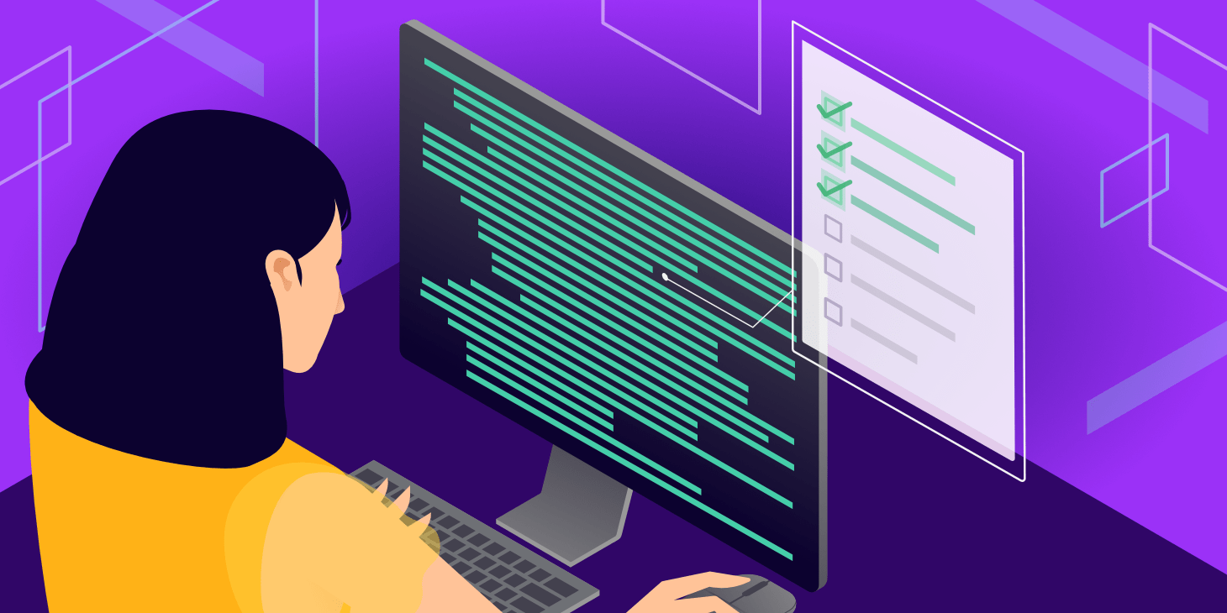

The intermediate stage is also about honing your problem-solving skills. You become a code detective, adept at breaking down large challenges into smaller, manageable steps. Debugging becomes second nature, where you identify and fix errors in your code with finesse. Cleanliness becomes a priority, as you write well-structured and readable code, just like a well-organized kitchen is essential for a smooth baking experience. Testing becomes your quality control, where you ensure each part of your code functions flawlessly before the final product emerges.

This newfound knowledge empowers you to create more substantial projects. Imagine building a text-based adventure game, a program to analyze your favorite music collection, or even a simple web application. The possibilities are vast, and with consistent practice, you'll transform from a confident baker of basic programs to a coding chef, whipping up impressive and functional applications.